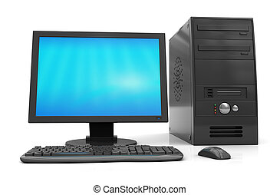HARDWARE COMPONENTS OF COMPUTER

<https://cdn.xxl.thumbs.canstockphoto.com/3d-illustration-of-black-desktop-computer-over-white-background-stock-images_csp8241665.jpg>

COMPUTER

Computer is an (high speed) electronic computing & data processing device, which takes inputs, processes it & produces . the output accordingly . it also store information in memory.